**Abstract** (<350 words @ Functional Ecology)

1. Purpose

2. Methods

3. Results

4. Discussion

**Introduction**

The extent to which community assembly mechanisms are deterministic processes i.e. niche based is a central topic in ecology. There are two major hypothesized processes that predict contrasting but non-exclusive patterns in the trait and spatial distributions of coexisting species. Environmental filtering structures communities by only allowing only organisms capable of surviving local conditions to persist within the local species pool (Vellend 2010). This mechanism can lead to a convergence in ecological attributes or traits among species in that area. In deserts, traits that allow organisms to cope with environmental stressors such as water stress and temperature extremes are common. In contrast, limiting similarity predicts that competitive exclusion results among ecologically similar species (Abrams 1983). This mechanism can lead to a divergence in traits among coexisting species. These processes work together but at differing scales, at large scales habitat filtering is expected to be stronger than biotic interactions, whereas at the fine scales that interactions actually occur at, biotic interactions prevail.

Ants are ideal system to test assembly processes…

Functional traits reflect aspects of morphology, life history or physiology that enable an organism to be successful in an environment (Violle et al. 2007). Plant ecologists have incorporated the role of facilitation by foundation plants into trait-based community assembly theory (Schöb et al. 2012). In deserts, shrubs reduce environmental stress by reducing daytime heat and retaining warmth overnight, creating locally stable micro-climates (McIntire and Fajardo 2014). Shrub facilitation often increases the cover and biomass of annual plants (Holzapfel et al. 2006, Pugnaire et al. 2011), as well as arthropod species richness and abundance beneath the canopy (Liu et al. 2016, Braun and Lortie 2020, Braun et al. 2021). Surface complexity can act as a filter on ant traits, for example longer-legged ant species are more successful on rugose surfaces that short-legged species (Kaspari and Weiser 1999). Therefore, at fine scales, there is the capacity for foundation shrubs and ground-covering vegetation to alter taxonomic composition, trait distributions and coexistence patterns of the ant community.

The relative importance of environmental and biotic filtering mechanisms to can change along environmental gradients. The stress gradient hypothesis proposes that competitive interactions decrease in importance as environmental stress increases (Bertness and Callaway 1994). There is extensive empirical support for the stress gradient hypothesis in plant communities (Lortie and Callaway 2006, He et al. 2013), however, in animal communities, tests are relatively rare. Due to the ecological importance and dominance of ants in arid ecosystems, understanding how their communities may change under increasing stress and along climatic gradients is important research to predicting the outcome of global change on these ecosystems.

We studied desert ant community assembly. We hypothesized that desert ant communities are assembled through niche-based processes.

We expect the following the predictions:

1. There will be evidence for filtering on ant communities through the following responses to environmental gradients: a) alpha and beta diversity, b) trait convergence or divergence i.e. changes to functional dispersion, and c) specific trait by environment interactions (community weighted mean trait values)
2. Species that are more similarity in terms of their environmental niche will be more similar in terms of their traits
3. Effect size measure of the trait dispersion of co-occurring ants will decrease with stress (stress gradient).

community trait composition (community weight mean trait values) -> This is the db-RDA

**Methods**

*Field collection*

Ant communities were sampled using pitfall traps at nine sites in the San Joaquin Valley, California, USA that span a distance of ~200 km from north to south. Summer of 2020. The shrub species *Ephedra californica* (Ephedraceae) and *Atriplex* sp. are the dominant perennial species at six of the sites and the remaining three sites are relatively open with few shrubs. White plastic drink cups (12.4 cm tall, 9 cm diameter) were placed with the top of the cup flush with the ground. In order to prevent vertebrate bycatch, 0.5-inch hardware cloth was placed horizontally within the trap and a piece of aluminum flashing was elevated three cm above the trap to shelter the trap. The traps were filled to a depth of three cm with 100% propylene glycol. Propylene glycol is a biodegradable, non-toxic preservative that does not evaporate and preserves DNA (Nakamura et al. 2020). At shrub sites, traps were placed at 12 pairs of shrub/open microsites and pairs were located at least 10 m apart. Shrub microsites were located beneath the canopy of a foundation shrub at the center of a 0.5 m quadrat placed just inside the dripline of the shrub. Open microsites were located randomly at least 2 m away from shrub microsites. At sites without shrubs in collections areas (i.e. within 500 -1000 m of collections), pitfalls traps were deployed every 10 m in open areas along two transects located at least 10 m apart. At each site, 24 pitfall traps were deployed continuously for 72 hours per sampling event. The traps were deployed in different locations within the study site each sampling instance to avoid repeated measures. Throughout the season, 648 traps were deployed totaling 46 656 trap-hours (24 traps per site * 3 sampling events * 72 hours). During each sampling instance, microsite-level vegetation characteristics were estimated. At each pitfall trap location, we measured the percent cover of ground-covering vegetation, rocky cover, woody cover and bare ground. Vegetation height was measured at the center of the quadrat and the dominant vegetation type was recorded. At shrub microsites, we measured the longest dimension of the shrub canopy axis, its perpendicular width, and the height of the focal shrub to the tip of the highest green tissue (Lortie et al. 2018). Site-level vegetation characteristics were measured each month by placing 0.5 m quadrats every 4 m in ten 25 m transects distributed around the site and repeating the microsite level measurements. Each sampling location was georeferenced using a handheld GPS unit.

*Lab work*

Ants were first identified to genus using Fisher & Cover (2007), and to species using AntWiki keys (www.antwiki.org). Representative individuals of each species were also barcoded and compared to BINs in BOLD systems. Two singletons, *Solenopsis molesta* and *Solenopsis aurea* were excluded from analyses. I measured the following morphological trait data from the ant specimens: Weber’s length (Brown 1953), which is the length of the longest diagonal on the thorax and a measure of overall worker body size. Femur length relates to foraging ability in complex environment and thermoregulation (Feener Jr et al. 1988), mandible length and head size with relate to diet, scape length relates to chemosensory abilities and eye size relates to forage behaviours (Weiser and Kaspari 2006). The latter six traits were divided by Weber’s body length to remove the impact of body size.

I measured each of the seven traits in up to six individuals per species, per site (265 individual ants) to capture the intraspecific variation between populations. The majority of functional ecology papers use traits measured at the species-level (de Bello et al. 2021), however traits captured at the population-level can better reflect environmental filtering (Jung et al. 2010, Violle et al. 2012) and may represent local adaptation (Kawecki and Ebert 2004). I dissected each ant and affixed them to microscope slides using Elmer’s glue. I placed each ant mount slide on top of a stage micrometer slide and took focus-bracketed photographs using a Canon 60D DSLR camera with a 60 mm macro lens and Canon EF 25 II extension tube. Helicon Focus software was used to combine the focus stacks into single images. I imported each composite image into ImageJ software, used the micrometer divisions within the image to calibrate the measurement scale within the software and measured each trait using the software.

*Analysis*

We extracted MAP (mean annual precipitation), mean annual temperature and maximum annual temperature for each site from WorldClim (Fick and Hijmans 2017). We extracted NDVI (normalized…) from EVIIRS (USGS EROS Visible Infrared Imaging Radiometer Suite), 375 m spatial resolution and 7 or 14 day temporal resolution (USGS, 2021). We used the NDVI measurement from the data closest to the field sampling date. NDVI represents the… and therefore can be used as an estimate of plant productivity (citations for that). We extracted several below-ground soil temperatures: mean annual soil temperatures and the range of soil temperatures as a measure of variability, both at the 5cm to 15 cm depth (Lembrechts et al. 2022).

All analyses used R version 4.1.0 (R Core Team 2022). I converted the abundance-based data to occupancy-based because ants forage socially and this leads to clustering of individuals from the same colony (Longino and Coddington 2002). Also, some pitfall traps were disturbed in the field. Thus, abundance for the purpose of abundance weighted calculations is the proportion of pitfall traps at the site the ant species was detected in.

Because of co-linearity within the environmental variables, we combined them into a composite environmental gradient using PCA (whatever package). The variables were first standardized to a ? (decostand, vegan). We also combined the population traits into a PCA.

I calculated functional dispersion (FDisp) for each of the 27 sites using the population-level trait means using the dbFD functioning in the FD package (Laliberté et al. 2014). In order to determine whether the site is functionally clustered or dispersed relative to a randomly assemble community, we compared the observed communities to a randomly assembled. I generated 1000 random communities using the RandomizeMatrix function in the picante package. The null models are the independent swap, which holds rows sums i.e. species richness and column sums i.e. occupancy/abundance of the population while randomizing everything else. FDisp was calculated for each of these 1000 matrices. Standardized effect size (SES) was then calculated for each site using the following formula: (Obs – MeanRandom)/SD Random (Swenson 2014). Positive values of SES indicated that a community is functionally dispersed, whereas negative values indicate functional trait clusterings (de Bello et al. 2021). A one sample t-test was used to determine of the mean values of all the sites is significantly different than zero i.e. clustered or dispersed (de Bello et al. 2021). In order to understand how environmental filtering acts along the environmental gradient, we regressed the FDispSES scores against the first axis of the PCA (PC1).

In order to understand the relative contributions of environmental variables, pure space and spatially something environmental variable, we did variance partitioning. We converted our WGS lat/long coordinates to cartesian coordinates using the geoXY function in the SoDA package (Chambers 2020). We then created moran’s eigenvector maps (MEMs) from the cartesian coordinates using the dbmem function in adespatial (Dray et al. 2018). The function varpart from vegan (Oksanen et al. 2010) was used using the SES values as the response, and the standardized environmental variable matrix i.e. the same as the pca input and the mem matrix as predictors.

We calculated the community-weighted mean trait values for each individual trait using the dbFD function in the FD package (Laliberté et al. 2014). In order to connect specific traits with the environmental gradient, we regressed each trait against the PC1 axis.

We regressed species richness against the PC1 axis.

Taxonomic beta-diversity?

*Large scale environmental niche overlap*

We conducted an additional set of analyses to explore the relationship between overall niche overlap and trait overlap. To determine niche overlap… We extracted occurrence data from gabi, a taxonomally verified database of ant occurrence data. We only used data from USA and Mexico (not islands). We thinned? The data points? Then built maxent species distribution models for each of the 11 species. We used world clim, soils and ndvi. We used ndvi from the middle month. We determined the pairwise overlap. It give a pairwise value D. We then used Mantel tests (or partial mantels maybe?) on the pairwise gower dissimilarity in species traits to test for a relationship between niche similarity and overall trait similarly.

**Results**

A total of 15519 individual ants from 11 species were collected and identified. All species are native to California. The most abundant species are *Solenopsis xyloni*, the native Southern fire ant, and *Pheidole hyatti*, the big-headed ant. This pitfall trapping was part of a larger arthropod sampling project that included sweep-netting of open areas and shrubs, as well as malaise trapping. There were no additional species detected using the other methods. On average, species richness per site was x and ranged from x to x.

The first PCA axis explained 48.16% of the variation. Precipitation, max and mean annual temperature and vegetation height were the greatest environmental contributors to the axis. The composite environmental gradient was therefore cooler, wetter sites (negative PC1 values) to hotter, drier sites (positive PC values).

*Taxonomic diversity patterns*

Alpha diversity does not shift with PC1.

The majority of taxonomic beta diversity comes from the turnover component (species replacement) (87.9%). Nestedness or gains losses is 12.1%. Mantels showed that the nestedness component of betadiversity is related to dissimilarity in the environment (Mantel r: 0.164, p = 0.028), but not the turnover component (Mantel r: 0.082, p = 0.135).

*Assembly*

Mean SES functional dispersion (mean = 0.58 +/- ) was significantly greater than zero (t-test, t = 3.54, p = 0.002). The values of SESdisp decreased as PC1 increased (Radj = 0.165), (coef = -0.507, p = 0.019) but not PC2 (coef = 0.17, p = 0.4) (Figure 2). SESdisp was not different between sites with large foundation shrubs vs open areas (p = ~0.86).

*Variance partitioning*

Environmental predictors explained 19% of the variation in SESfdisp and spatially distributed? Environmental variables explained 32% of the variation (Figure 3). The contribution of pure space was zero.

*Community-weighted mean traits*

Weber’s body length (AdjR2 = 0.26, p = 0.004) and relative femur length (AdjR2 = 0.243, p = 0.005) both decrease along the PC1 gradient (Figure 4). The other traits are not linearly related to the PC1 gradient. The contribution of taxonomic identity to trait variation varied with the trait (Figure 5).

Figure 1: PCA figures

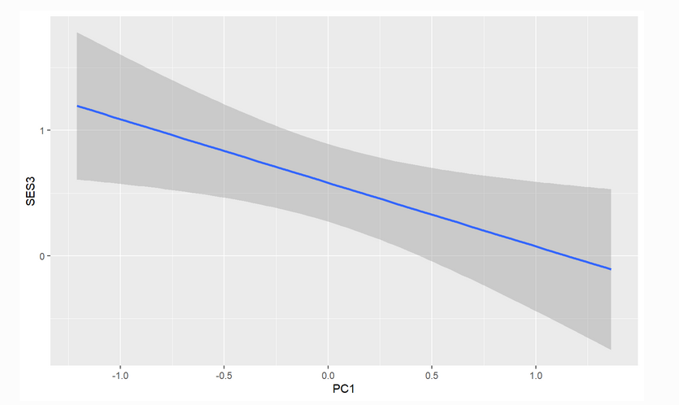 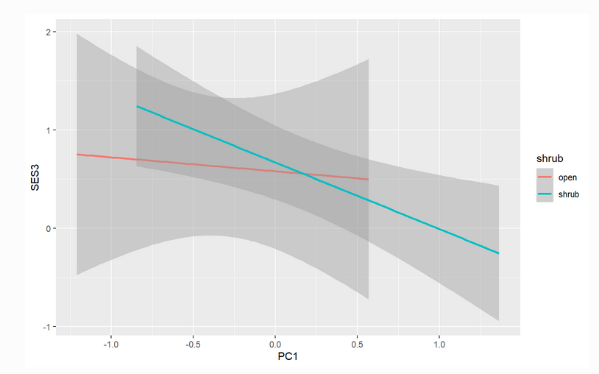

Figure 2: SESdisp regressed against PC1

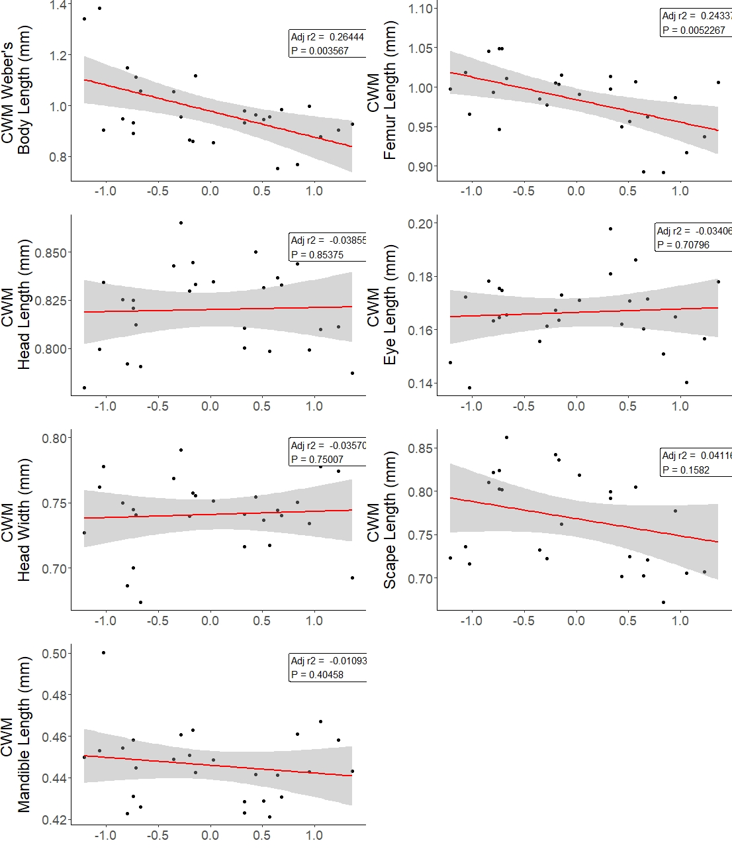

Figure 3: Linear regressions of community-weighted mean trait values and the composite environmental gradient (PC1). Sites with higher annual temperatures and lower annual precipitation are higher on the PC1 gradient. The shaded gray band represents the 95% confidence interval.

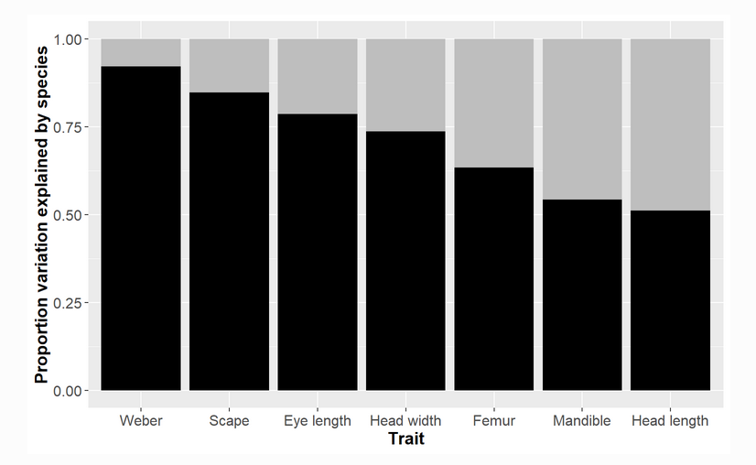

Figure 5: ITV and traits

**Discussion**

P1: Hypothesis, predictions. Overall assembly conclusions. Environmental and biotic filtering acts jointly.

P2: Assembly processes are scale-dependent

P3: Contrast stress gradient predictions for ants vs plants

P4: Discussion on implications for body size and femur length CWM along gradient

**Appendix**

Table 1: Summary of sampling dates and locations.

|  |  |  |  |  |  |
| --- | --- | --- | --- | --- | --- |
| Site Name | BNLL presence | Sampling dates | | Coordinate of site centroid | |
| **Traps** | **Active** |
| CaS | present | July 10 - 13 | July 10, 12 | 35.11995 | 119.6283 |
| Aug 2 - 5 | Aug 3, 4, 5 | 35.12000 | 119.6280 |
| Sept 18 - 21 | Sept 19, 21 | 35.11600 | 119.6240 |
| CaSl | present | July 9 - 12 | July 9, 12 | 35.09 | -119.574 |
| Aug 2 - 5 | Aug 2, 3, 4 | 35.089 | -119.576 |
| Sept 18 - 21 | Sept 18, 19 | 35.065 | -119.539 |
| SemiT | present | July 15 - 18 | July 17, 18 | 35.658 | -119.612 |
| Aug 6 - 9 | Aug 6, 9 | 35.658 | -119.612 |
| Sept 24 – 27 | Sept 24, 27 | 35.658 | -119.61 |
| Lokern | present | July 14 - 17 | July 14, 15 | 35.354 | -119.584 |
| Aug 3 - 6 | Aug 4, 5 | 35.354 | -119.584 |
| Sept 23 - 26 | Sept 23, 26 | 35.355 | -119.588 |
| PaPl | present | July 23 - 27 | July 23, 27 | 36.698 | -120.799 |
| Aug 12 - 15 | Aug 13, 14 | 36.696 | -120.795 |
| Sept 10 -13 | Sept 10, 13 | 36.7 | -120.801 |
| Aven | absent | July 21 - 24 | July 21, 22 | 36.094 | -120.197 |
| Aug 8 - 11 | Aug 10, 11 | 36.088 | -120.19 |
| Sept 6 - 9 | Sept 7, 9 | 36.0878 | -120.1912 |
| Mov | absent | July 28 - 31 | July 28, 29 | 36.563 | -120.547 |
| Aug 13 - 16 | Aug 13, 14 | 36.562 | -120.545 |
| Sept 12 - 16 | Sept 12, 14 | 36.561 | -120.548 |
| SiCr | absent | July 20 - 23 | July 21, 22 | 36.586 | -120.687 |
| Aug 12- 15 | Aug 12, 13 | 36.586 | -120.686 |
| Sept 12 - 16 | Sept 14, 16 | 36.586 | -120.688 |
| Coal | absent | July 16 - 19 | July 16, 19 | 36.213 | -120.305 |
| Aug 8 - 11 | Aug 8, 10 | 36.212 | -120.304 |
| Sept 6 – 9 | Sept 6, 7 | 36.213 | -120.303 |

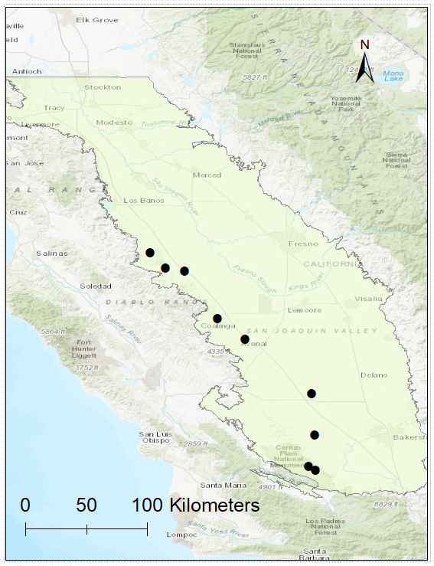

Figure 1: A map of the nine study areas.

Table 2: Scene ID

|  |  |  |  |  |
| --- | --- | --- | --- | --- |
| eVIIRS NDVI | EVUSS20200630202007066 | EVIIRS NDVI 375M | 154.78 MiB | Complete |
| eVIIRS NDVI | EVUSS20200707202007136 | EVIIRS NDVI 375M | 155.12 MiB | Complete |
| eVIIRS NDVI | EVUSS20200714202007206 | EVIIRS NDVI 375M | 154.11 MiB | Available |
| eVIIRS NDVI | EVUSS20200714202007276 | EVIIRS NDVI 375M | 169.38 MiB | Complete |
| eVIIRS NDVI | EVUSS20200721202007276 | EVIIRS NDVI 375M | 154.01 MiB | Complete |
| eVIIRS NDVI | EVUSS20200728202008036 | EVIIRS NDVI 375M | 154.96 MiB | Available |
| eVIIRS NDVI | EVUSS20200728202008106 | EVIIRS NDVI 375M | 170.24 MiB | Complete |
| eVIIRS NDVI | EVUSS20200804202008106 | EVIIRS NDVI 375M | 155.96 MiB | Available |
| eVIIRS NDVI | EVUSS20200811202008176 | EVIIRS NDVI 375M | 155.71 MiB | Available |
| eVIIRS NDVI | EVUSS20200811202008246 | EVIIRS NDVI 375M | 168.62 MiB | Available |
| eVIIRS NDVI | EVUSS20200818202008246 | EVIIRS NDVI 375M | 153.81 MiB | Available |
| eVIIRS NDVI | EVUSS20200825202008316 | EVIIRS NDVI 375M | 153.74 MiB | Available |
| eVIIRS NDVI | EVUSS20200825202009076 | EVIIRS NDVI 375M | 167.25 MiB | Available |
| eVIIRS NDVI | EVUSS20200901202009076 | EVIIRS NDVI 375M | 152.77 MiB | Available |
| eVIIRS NDVI | EVUSS20200908202009146 | EVIIRS NDVI 375M | 147.03 MiB | Available |
| eVIIRS NDVI | EVUSS20200908202009216 | EVIIRS NDVI 375M | 162.40 MiB | Available |
| eVIIRS NDVI | EVUSS20200915202009216 | EVIIRS NDVI 375M | 150.21 MiB | Available |
| eVIIRS NDVI | EVUSS20200922202010056 | EVIIRS NDVI 375M | 162.86 MiB | Available |

*From <*[*https://dds.cr.usgs.gov/queue/orderlist/BulkDownload/20220822_104216/1*](https://dds.cr.usgs.gov/queue/orderlist/BulkDownload/20220822_104216/1)*>*

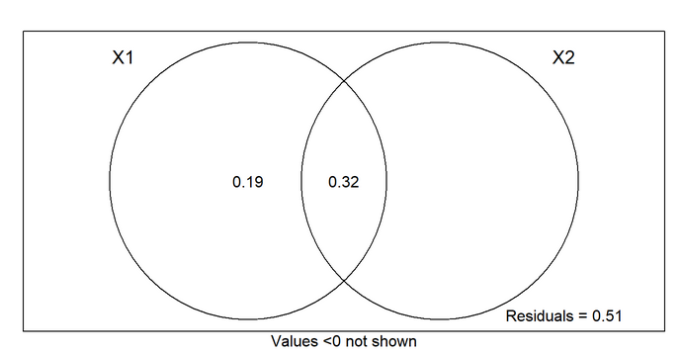

Figure 3: Variance partitioning

Supplemental Information

Table S1: Population level trait measurements

Literature Cited

USGS EROS Archive - Vegetation Monitoring - EROS Visible Infrared Imaging Radiometer Suite (eVIIRS) , https://doi.org/10.5066/P9Q3B2A7